Please complete this questionnaire in black ink. The following information is important to your health. Please take the time to accurately and completely fill this out.

PATIENT HISTORY

Name: _____________________________________ Date of Birth: ___________________

Gender: M F Age: ____________

Hair Loss History: Age of onset of hair loss: ________
Above average hair loss recently: □ Yes □ No

What are your current hair loss concerns?

□ Starting to thin
□ Advanced stage of thinning
□ Receding hairline
□ Bald spot in the crown
□ Little or no hair on top of scalp
□ Thin eyebrows
□ Sparse eyelashes
□ Postoperative plastic surgery hair loss
□ Increased shedding of hair

Other:_______________________________________________________________________

Have you experienced the following conditions?
In the past Currently
Scalp tenderness or pain □ □
Scalp itching □ □

Have you used any of the following?
In the past Currently
Hair color □ □
Hair perm □ □
Hair piece □ □
Minoxidil (Rogaine®) treatment □ □
Finasteride (Propecia®) treatment □ □
Shampoo for thinning hair □ □
Vitamins/Minerals/Herbs □ □

Which of your family members have/had hair loss?

□ Mother
□ Mother’s Father
□ Mother’s Mother
□ Father
□ Father’s Father
□ Father’s Mother
□ Brother(s)
□ Sister(s)
□ Other(s)

Name:__________________________________________ Date of Birth:____________________
Please circle the diagram which you feel closely matches your hair loss pattern.
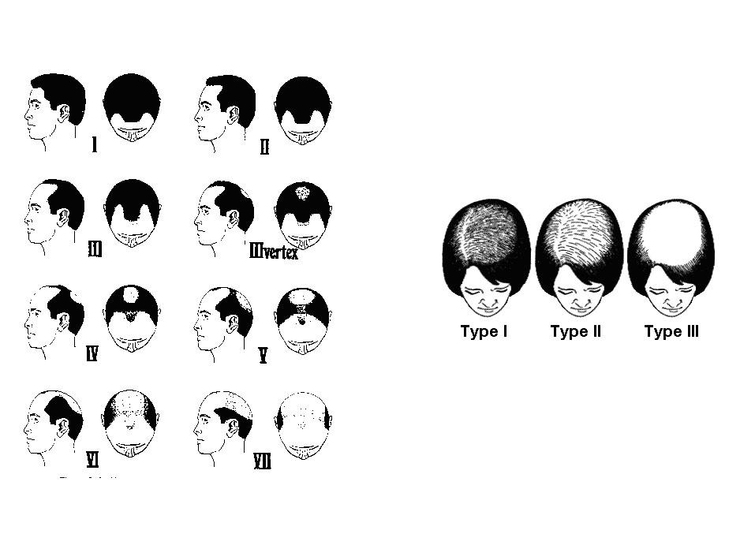

Which area(s) do you wish to restore:
□ Hairline restoration
□ Increase in frontal density
□ Crown coverage
□ Stop hair loss or decrease shedding
□ Touch-up, refinement, or correction of previous procedure
□ Scar coverage

Please state your goals and objectives:
_______________________________________________________________________________________________________________________________________________________________________________________________________________________________________________________________

Have you ever had any hair restoration procedures in the past? (If yes, please indicate date(s), area(s) transplanted, and number of grafts placed)
_______________________________________________________________________________________________________________________________________________________________________________________________________________________________________________________________
Please check all referrals that apply. (Who should we thank?)
□ Internet _______________________________________________________________
□ Newspaper _______________________________________________________________ □ Television _______________________________________________________________ □ Friend/Patient _______________________________________________________________
□ Other _______________________________________________________________
Name:__________________________________________ Date of Birth:____________________

Past Medical History: Please check YES or NO for every condition listed below.
YES NO YES NO
□ □ History of Alopecia Areata □ □ Lung Disease
□ □ Low Iron □ □ Stroke/TIA
□ □ Lupus □ □ Kidney Problems
□ □ Hair Pulling □ □ Diabetes
□ □ Thyroid Disease □ □ Cancer
□ □ Polycystic Ovarian Syndrome □ □ Rheumatic Heart Disease
□ □ Keloid Formation □ □ History of Rheumatic Fever
□ □ Scarring □ □ Mental Illness
□ □ Bleeding Disorder □ □ Depression/Anxiety
□ □ HIV/Hepatitis □ □ Asthma
□ □ High Blood Pressure □ □ Implants
□ □ Irregular Heart Beat □ □ Prosthetic Joints
□ □ Coronary Heart Disease □ □ Substance Abuse
□ □ Heart Murmur □ □ Problems with local anesthesia

Do you have any medical conditions that are not listed above?
______________________________________________________________________________________
Are you presently under the care of a physician for any of the above conditions?
______________________________________________________________________________________
Please list ALL surgery you have had including the date(s).
______________________________________________________________________________________
____________________________________________________________________________________________________________________________________________________________________________
Current Medications (please list all medications including over the counter medications; for example, aspirin or other blood thinners, vitamins, herbs, or supplements):
______________________________________________________________________________________
____________________________________________________________________________________________________________________________________________________________________________

Allergies (to medications.):___________________________________________________
Allergies to Latex: No Yes- Allergies to Iodine: No Yes- Allergies to adhesive: No Ye Allergies to Food : No Yes

Social History: Current occupation: ____________________________________________________
Smoking: □ Never smoked
□ Previous smoker (When did you quit?______________________)
□ Currently smoke ______ packs/day for ______ years
Alcohol: □ Daily □ Occasionally □ Rare □ Never
The above information is true and correct to the best of my knowledge.

_____________________________________ ___________________________
Signature of Patient Date

